**DAILY ONLINE ACTIVITIES SUMMARY**

|  |  |  |  |  |  |  |  |
| --- | --- | --- | --- | --- | --- | --- | --- |
| **Date:** | 29/05/2020 | | | | **Name:** | AMBIKA V | |
| **Sem & Sec** | 4th SEM SEC 'A' | | | | **USN:** | 4AL18CS005 | |
| **Online Test Summary** | | | | | | | |
| **Subject** | | 1.Data Communication  2.Complex analysis, probability and statistical methods. | | | | | |
| **Max. Marks** | | 30  30 | | **Score** | | 28  27 | |
| **Certification Course Summary** | | | | | | | |
| **Course** | 1.Artificial intelligence in Python  2.Introduction to Ethical Hacking | | | | | | |
| **Certificate Provider** | | | Greatlearning Academy | **Duration** | | | 7hrs  6hrs |
| **Coding Challenges** | | | | | | | |
| **Problem Statement:****1** Write a C Program to count Uppercase, Lowercase, special character and numeric values for a given String. | | | | | | | |
| **Status:** Completed | | | | | | | |
| **Uploaded the report in Github** | | | | YES | | | |
| **If yes Repository name** | | | | https://github.com/ambika0202/lockdown-coding- | | | |
| **Uploaded the report in slack** | | | | YES | | | |

**Online Test Details:**

DC test was scheduled from 09:15 am t0 09:55am .The portion for the IA was 3rd module and 4th module there were 30 questions and the time assigned was 45 minutes the questions were mcq type.

**Snapshot:**

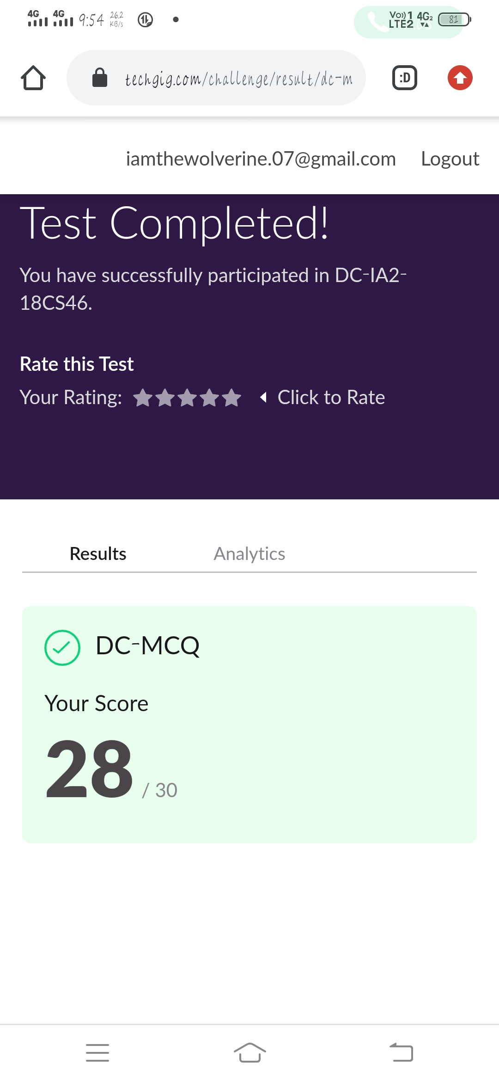

Maths test was scheduled from 03:00 pm to 03:40pm .The portion for the IA was module 3 there were 30 questions and the time assigned was 40 minutes the questions were mcq type.

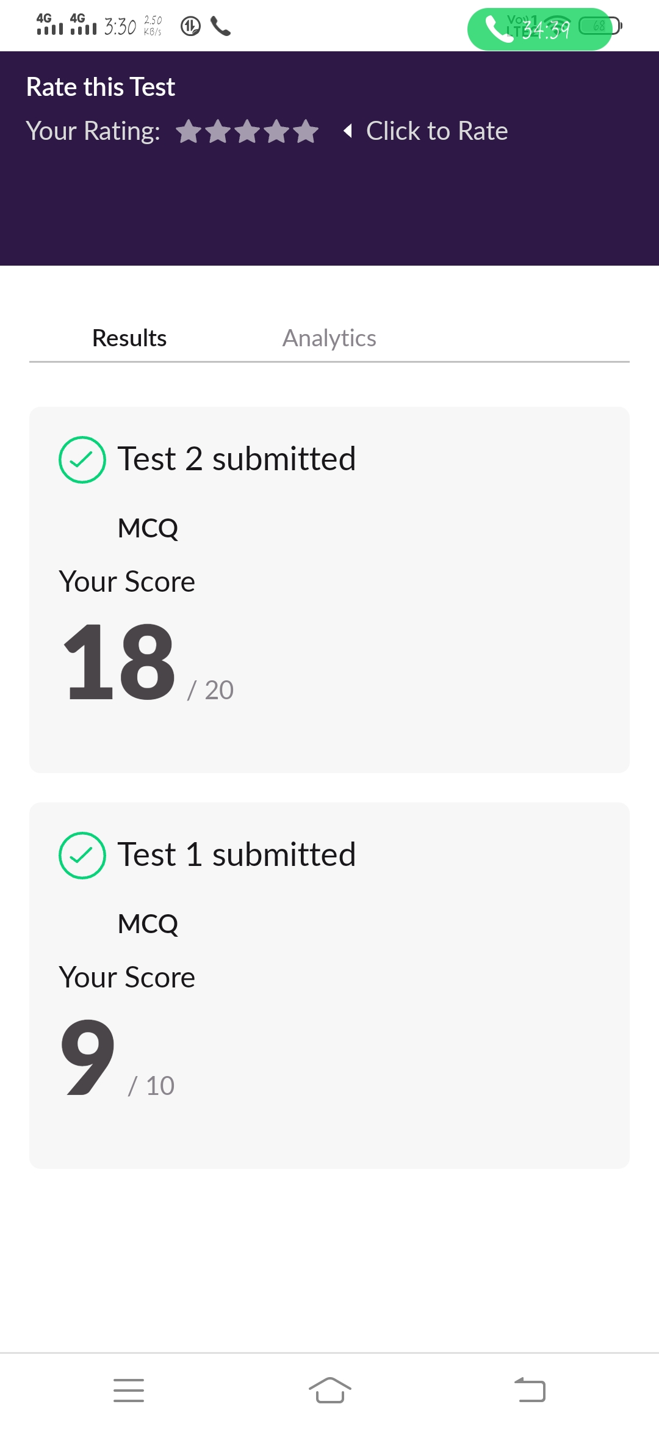

**Certification Course Details:**

**Name of the course**: Artificial intelligence in Python

**Certificate Provider**: Great Learning Academy

Python is a more popular language over C++ for AI and leads with a 57% vote among developers. That is because Python is easy to learn and implement. With its many libraries, they can also be used for data analysis. Performance wise C++ outperforms Python.

**Snapshot:**

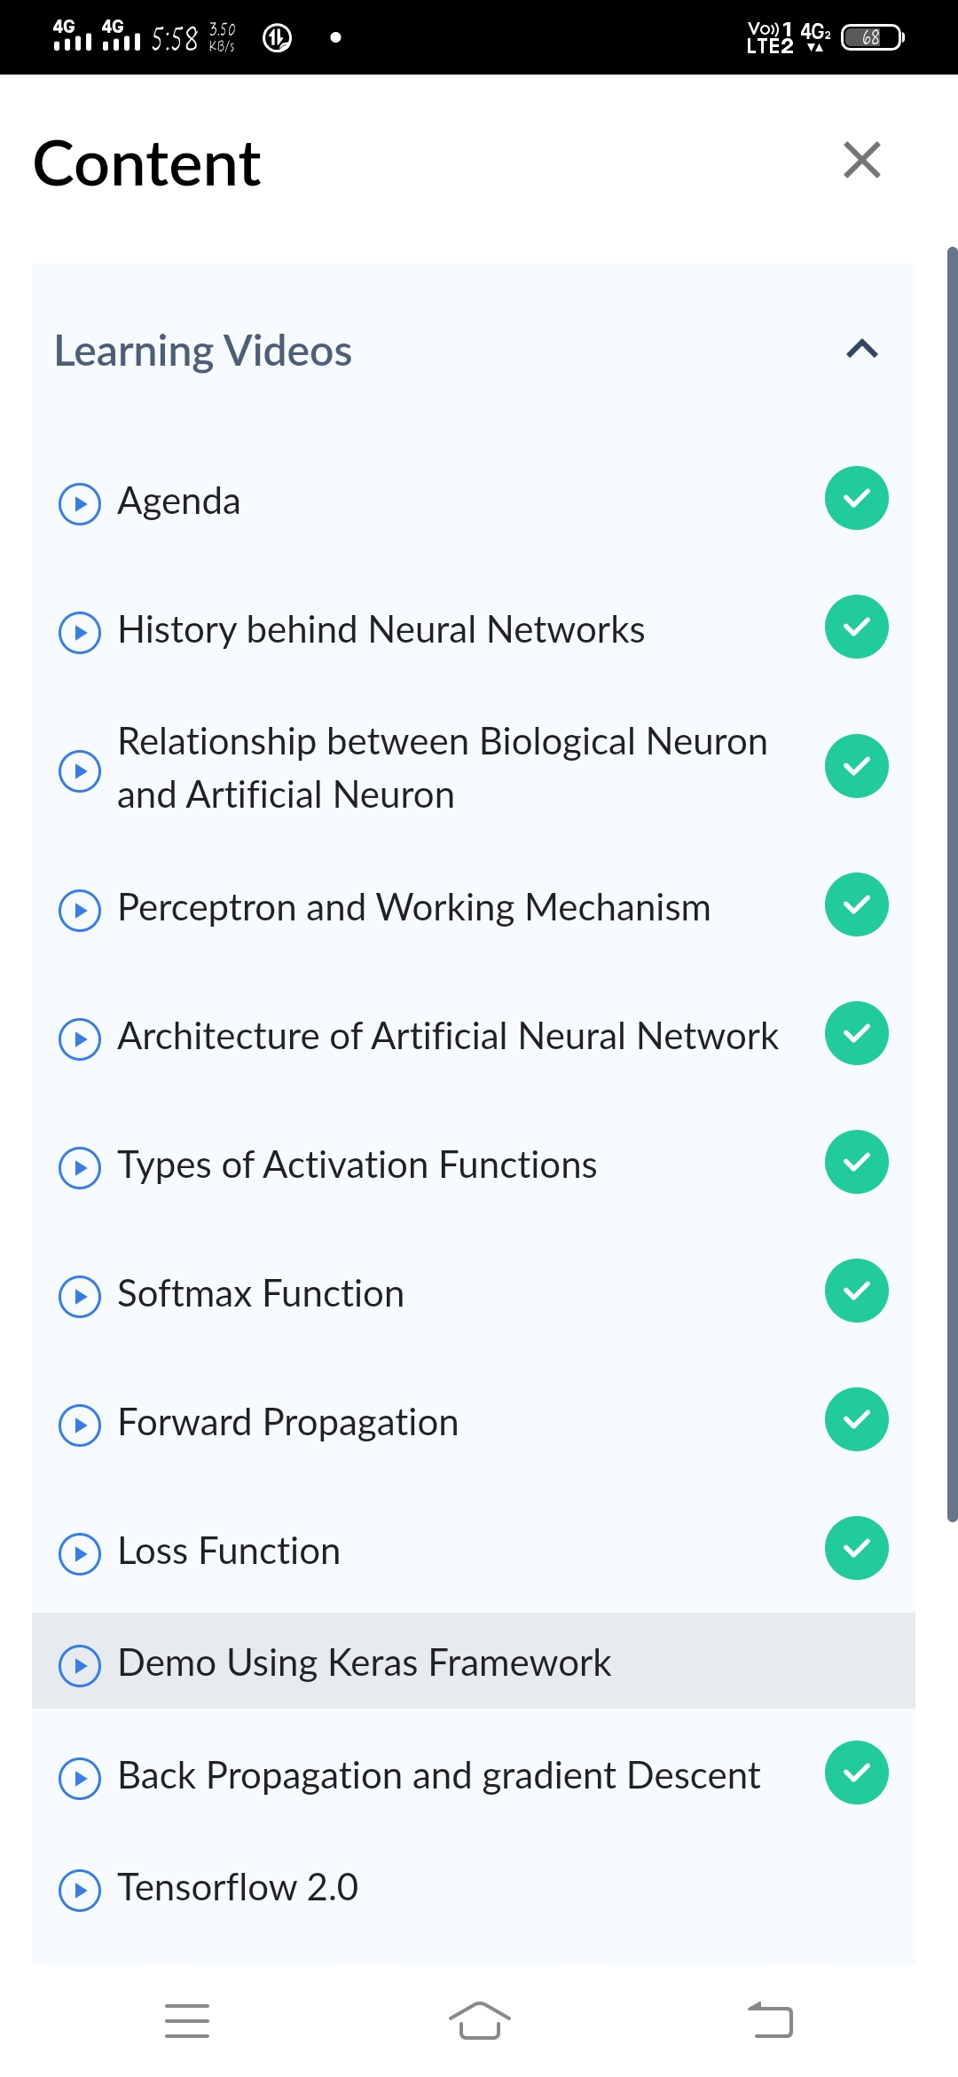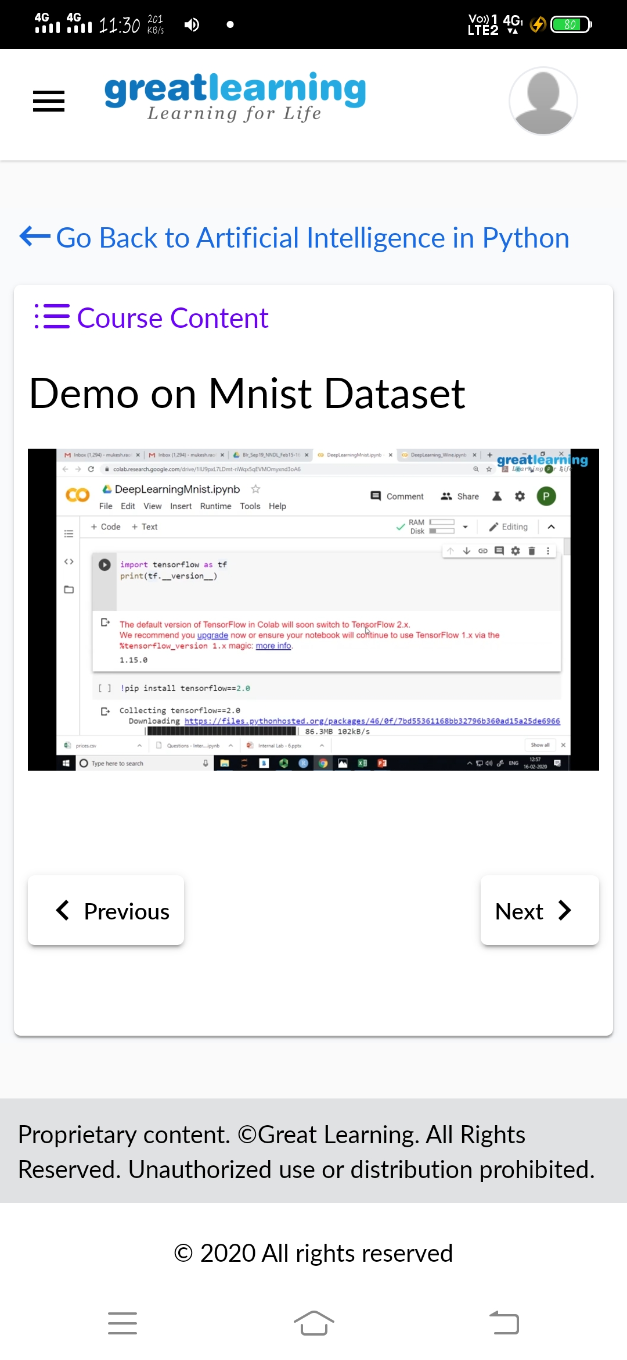

**Certification Course Details:**

**Name of the course**: Introduction to Ethical Hacking

**Certificate Provider**: Great Learning Academy

I have completed all the modules And attempted the quiz and received its certificate.

**Snapshot:**

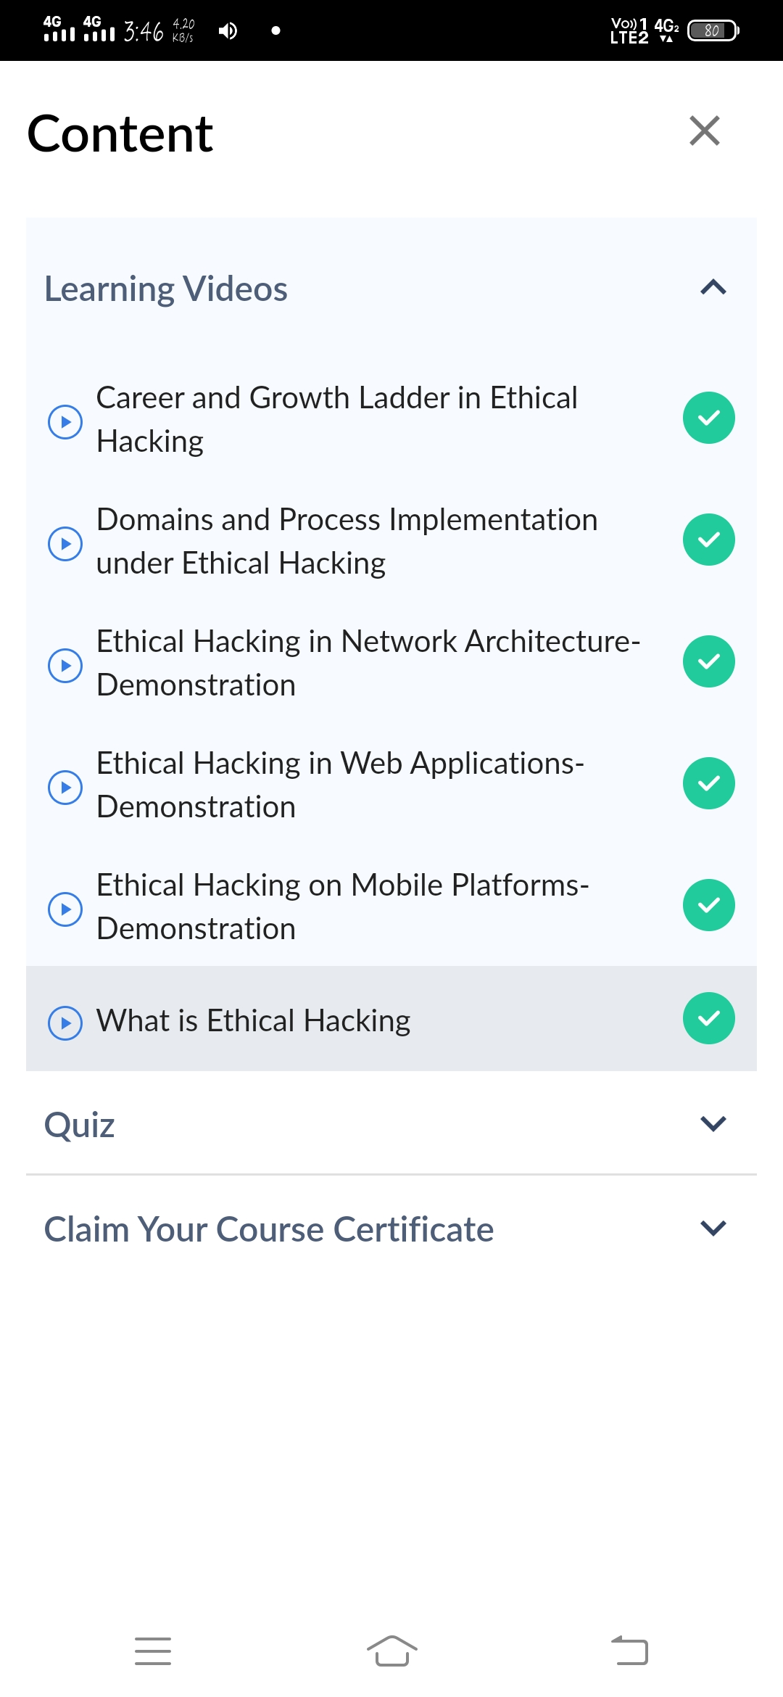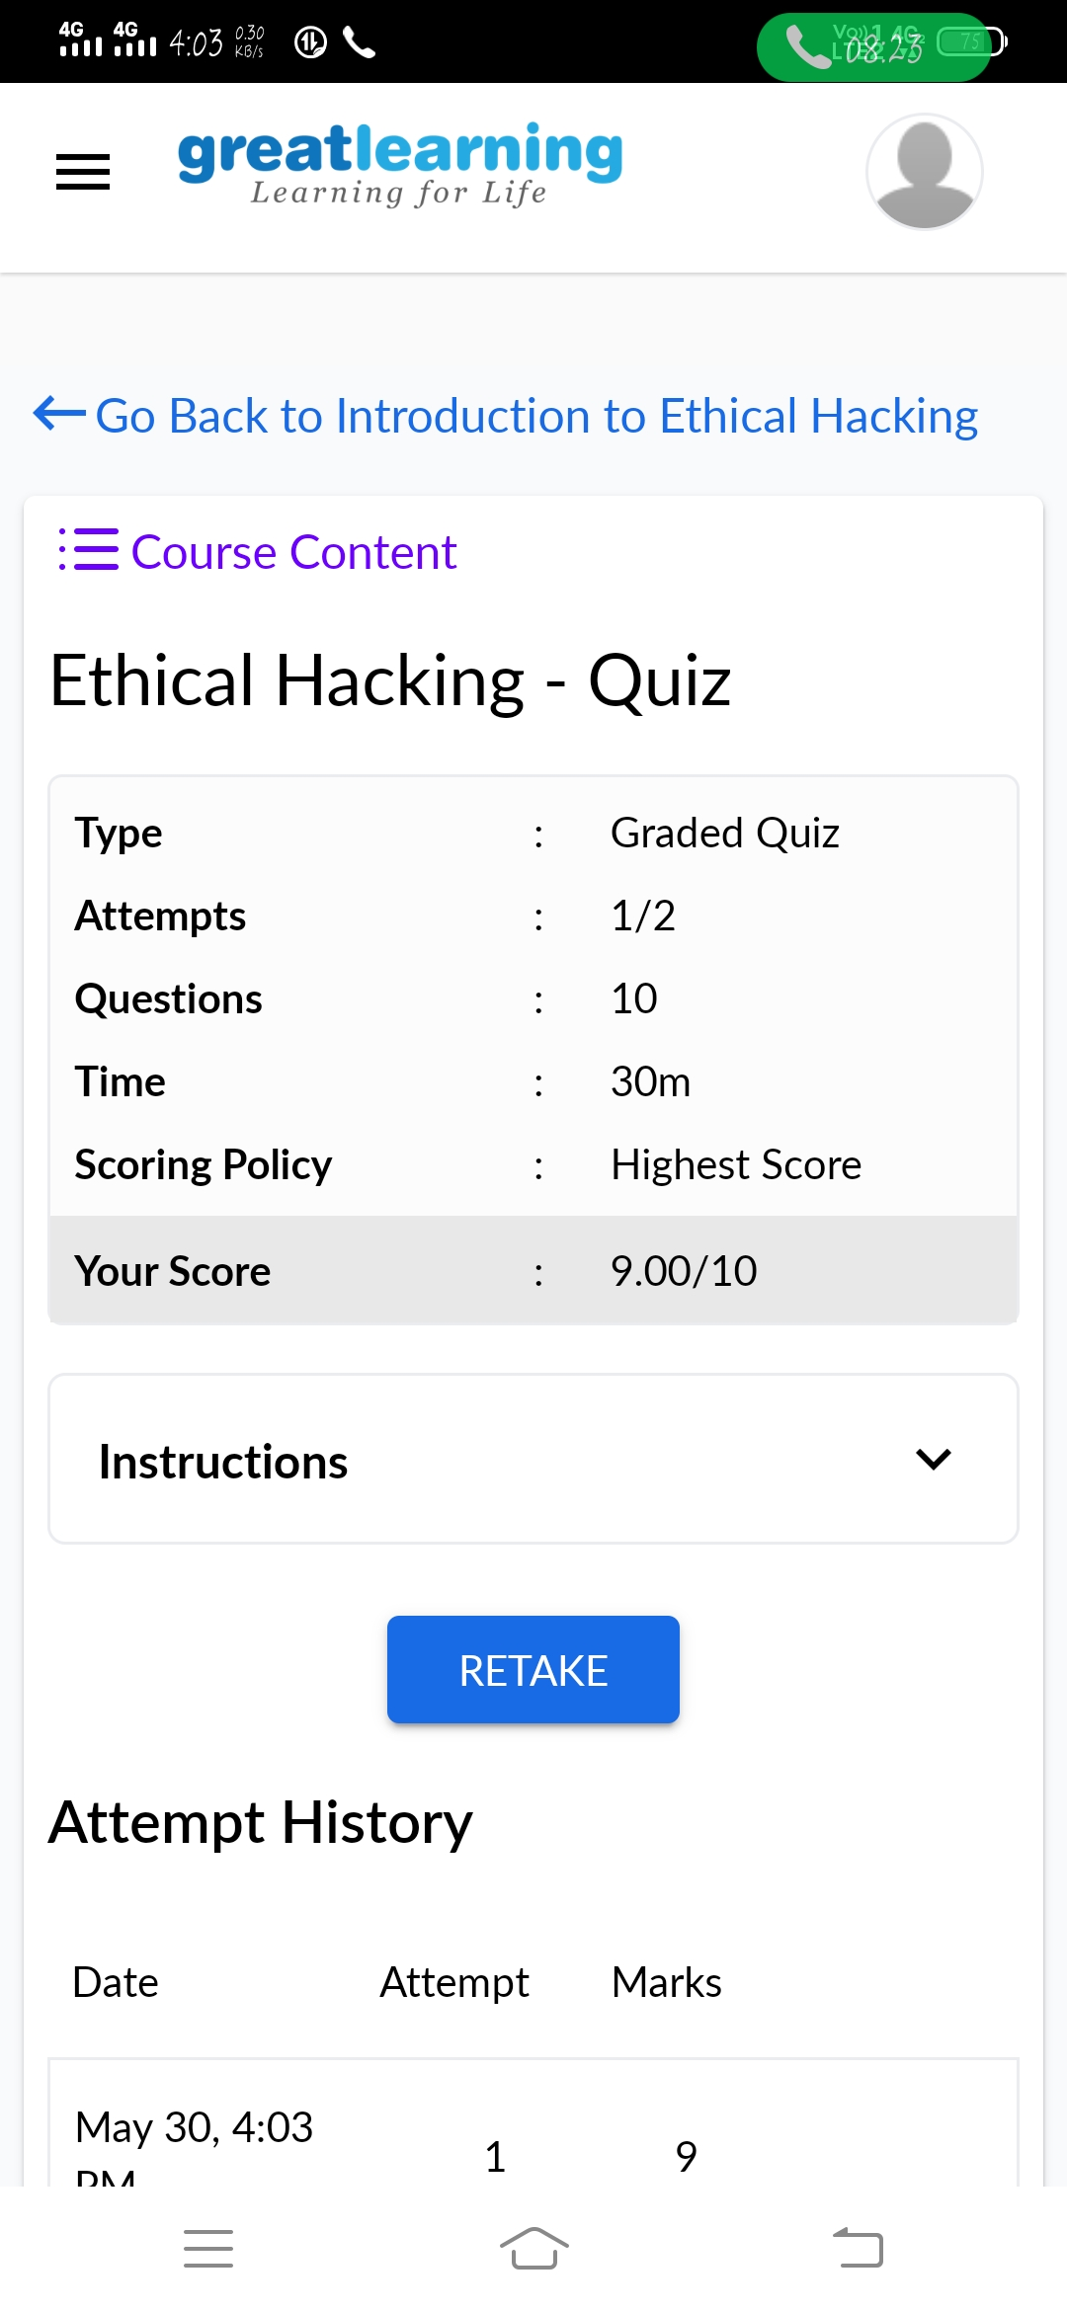

The below is a certificate issued by Greatlearning Academy

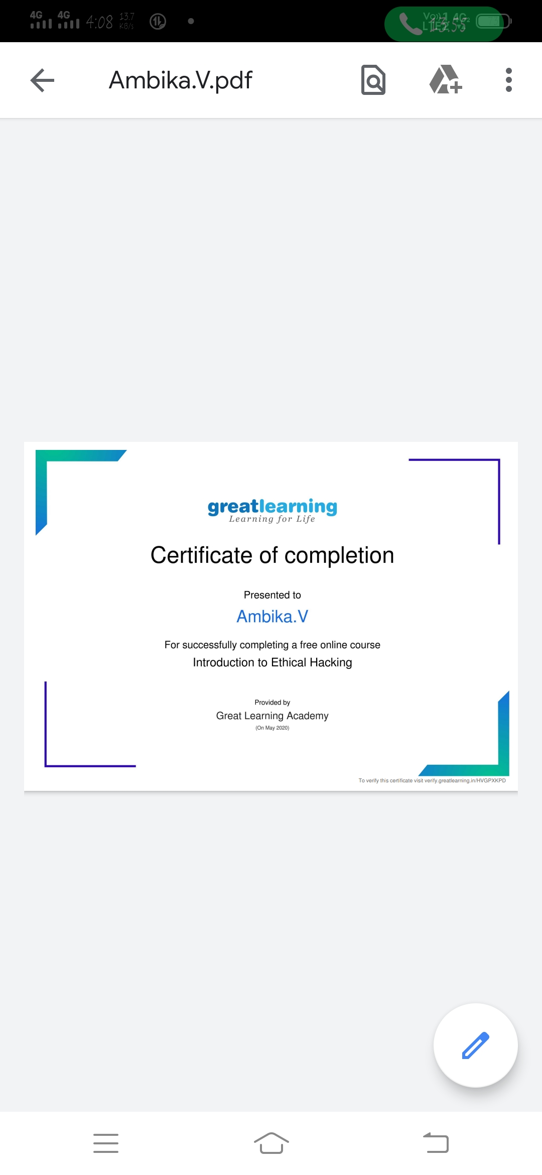

**Certification Course Details:**

**Name of the course**: Step into Robotic process Automation

**Certificate Provider**: Udemy

Robotic Process Automation is a software-based technology utilising software robots to emulate human execution of a business process. This means that it performs the task on a computer, uses the same interface a human worker would, clicks, types, opens applications, uses keyboard shortcuts, and more.

There were three steps.. introduction, beginner and intermediate and each of the consisted 4 different parts.. After completing this there was quiz for each part and I have went through all of them and received its certificate successfully.

**Snapshot:**

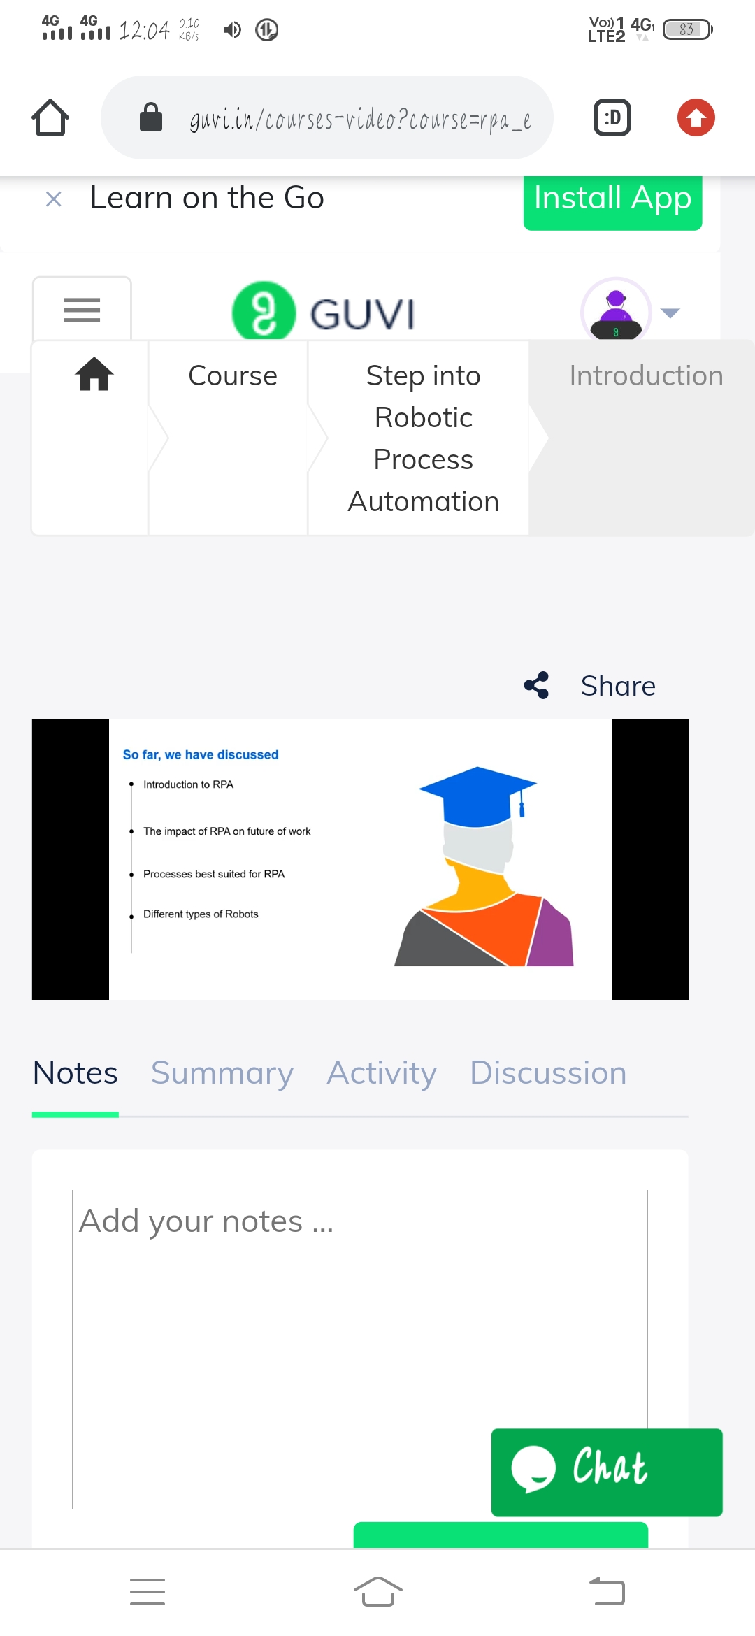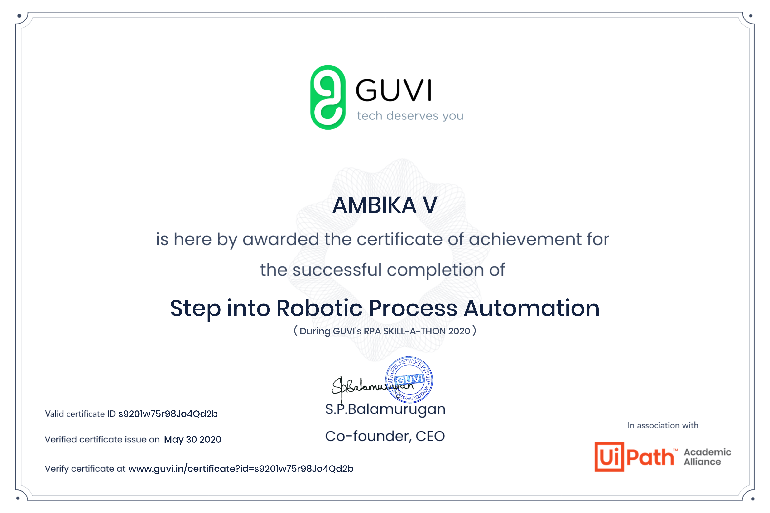

**Online Coding Details:**

**Problem statement 1:** Write a C Program to count Uppercase, Lowercase, special character and numeric values for a given String.

